Thank you for registering for Lusk 4 Mile 2025!
Number and T-shirt Pick up
You can pick up your number and t-shirt in:
Lusk National School
Saturday between 1pm and 4pm
Sunday from 12pm
Getting to Lusk
Dublin Bus route 33
Train Rush & Lusk Train Station is located 2.2km from the start/finish area.
Parking available in Round Towers GAA Club , Lusk Sports Hub Lusk Sports Hub
Please consider our neighbours when parking anywhere outside of the designated parking areas.
Bag Drop
Bag drop is available in Lusk National School, Chapel Road
PLEASE DO NOT LEAVE VALUABLES.
Toilets
Lusk National School
Portaloos
Round Towers GAA Club
Juvenile Races
The Thomas Ashe Dash starts at 2pm
Girls U8 – 400 Metres
Boys U8 – 400 Metres
Girls U12 – 800 Metres
Boys U12 – 800 Metres
Girls & Boys U16 – 1 Mile
Register on the day from 12pm Lusk National School - Entry €5.
Prizes for the top three in each race.
Lusk 4 Mile
Please follow the Marshal and Gardaí instructions at all times.
Race Start is 3pm.
We have 28min, 32min, 36min and 40min PACERS.
There will be a lead motorbike, 2 lead bikes.
The Lusk 4 Mile will start at the church gate on Chapel Road, running west towards Quickpenny Road and turning around the Green down Post Office Road. Then left to Main Street and head north towards Skerries Roundabout. Right onto the Rathmore Road coming back into the village at Station Road Roundabout and onto Station Road towards Main Street. Left up Post Office Road, Chapel Green and right at the top of the Green through the start line gantry and into Lap 2. Lap 2 will go into Lusk National School, left onto Main Street and continue onto Rathmore Road again. Finish will be up Post Office Road and right at Chapel Green to finish.
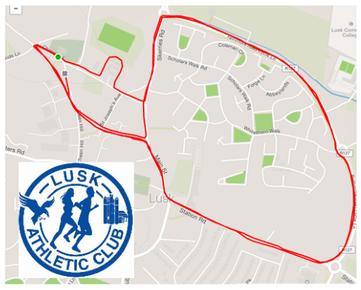
After you have completed the race please follow the marshal instructions and slowly and carefully move through the finish area where you will receive your finisher medal and collect your goodie bag.
Please enjoy some post race refreshments in Lusk National School Hall directly after the race while prize giving takes place.
Medal & Prize for 1st, 2nd and 3rd place male & female.
A Club prize first 4 counted. Mixed teams allowed.
Medal for O40, O50 and O60 age categories.
Enjoy the day & good luck to all participants.
Yours in Sport
Lusk Athletic Club

